Instructor Live Proctoring with Zoom and LockDown Browser

(Instructor Directions)

Respondus LockDown Browser is a custom browser that locks down the online testing environment within Canvas. When students use LockDown Browser with an online test, they are unable to print, copy, navigate to other websites, or access other applications.
LockDown Browser can be used with Instructor Live Proctoring. This feature allows the use of a video conferencing system, such as Zoom, with LockDown Browser. By using this feature, instructors are able to proctor students remotely during an online test by watching test takers via a videoconference. It is not designed to proctor an entire class. Instructor Live Proctoring is intended to provide a proctoring solution for a small number of students.
Instructor Live Proctoring does not automatically record the student video, nor does it alert the instructor to suspicious events. Therefore, it is up to the instructor to be vigilant in monitoring the students’ examinations.

Getting Started
Instructors are encouraged to contact CIRT for assistance with setting up Instructor Live Proctoring.
Step 1: Provide students with instructions for downloading and installing LockDown Browser prior to the examination. Instructors can view sample syllabus language on the UNF LockDown Browser information page.
IMPORTANT - UNF students will need to download the LockDown Browser application from this link: https://download.respondus.com/lockdown/download.php?id=482833918
Step 2: Create a quiz in Canvas and assign it to individual student(s). (Contact CIRT for help with creating a copy of an existing quiz.)
Step 3: Enable the exam with LockDown Browser.
- Select LockDown Browser from the Canvas Course Navigation menu, then locate the quiz title in the Respondus LockDown Browser dashboard.
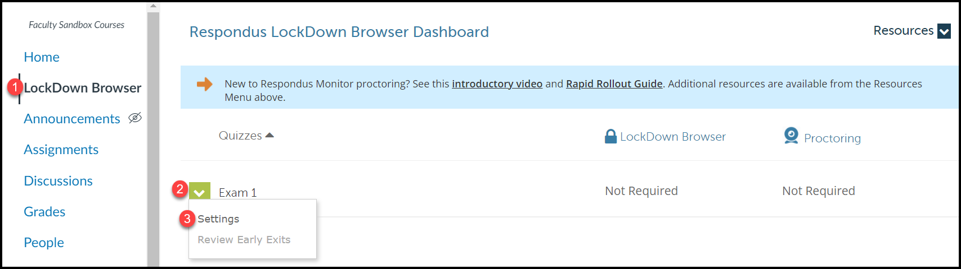
- Click on the arrow icon next to the title of the quiz and select Settings. Choose Require Respondus LockDown Browser for this exam. Select the option to Allow Live Proctoring, choose the video conferencing system (Zoom) from the dropdown menu, and create a Start Code.

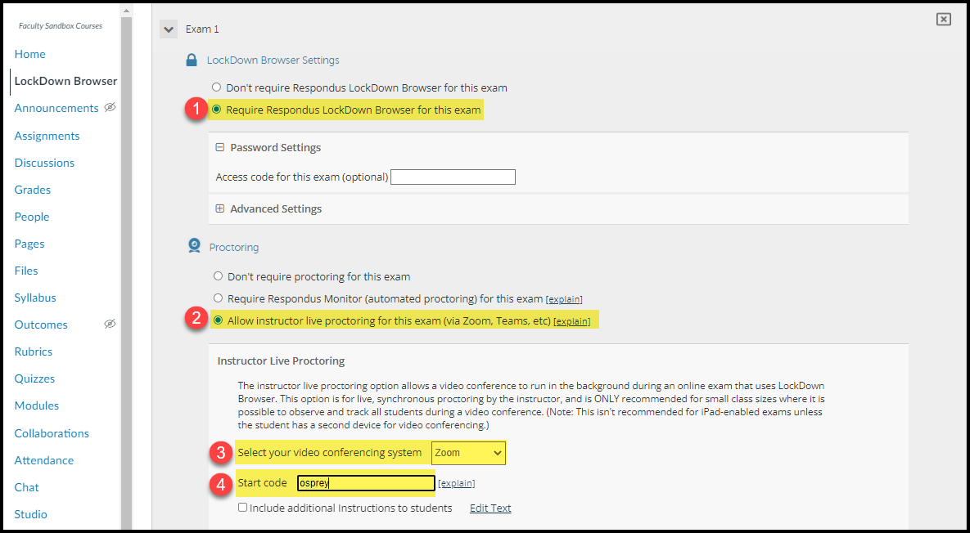

Note: You must have a Start Code and it should NOT be given to students ahead of time. This will be provided to students by the instructor when students are ready to begin the exam.
Step 4: Schedule a Zoom meeting through the Zoom Web Portal at https://unf.zoom.us/. Send the meeting link to the student(s) prior to the exam.
Note: Instructors should schedule the Zoom meeting using the Web Portal rather than the Zoom integration in Canvas because the meeting link will only be shared with the select student(s) taking the exam via Instructor Live Proctoring.

During the Exam
- Students must join the Zoom meeting first before opening LockDown Browser.
Note: Once students open LockDown Browser, they will not be able to see their Zoom meeting controls. Instructors should also consider whether it is preferred that students mute their microphones, and they should remind students that they will still be seen by the instructor even though students will not see the Zoom meeting window.

- Once all students have joined the Zoom meeting and can confirm that they are able to hear the instructor, consider asking students to perform a room scan of their testing environment. Remind students of the rules of the examination.

- Direct students to open the LockDown Browser application. This will automatically prompt them to log into their Canvas accounts, where they can then navigate to the test. (Remember, once students complete this step, they will not be able to see the Zoom meeting window or access their Zoom meeting controls.)

- Verbally provide students with the Start Code for the exam.

- Use the Gallery View feature in Zoom to monitor all students simultaneously during the exam

Ending the Exam
Once students submit the exam for grading, they will be able to close the LockDown Browser window and return to their Zoom meeting controls. Instructors may consider requiring the students to send a private chat message to the instructor which indicates that they have completed the exam and are leaving the Zoom meeting.

Things to Consider and Troubleshooting
- This tool is an alternative for students who are unable to take an exam in person due to extenuating circumstances. It is recommended that no more than 6 students should be proctored at one time using this feature.

- Instructors are highly encouraged to run a practice session with students before using LockDown Browser with Instructor Live Proctoring for an exam.

- Remind students that the Zoom meeting will continue to run in the background, enabling the instructor to see and hear them during the exam. However, students will not be able to access the Zoom window or meeting controls during the exam.

- An iPad will not allow students to run Zoom and LockDown Browser at the same time. For students who must use an iPad to complete their exam, consider allowing them to use a secondary device (such as a cell phone) for the Zoom meeting.

- Instructors and students should check for Zoom updates prior to the exam to ensure all Zoom participants are running the latest version of the desktop software.

- Instructors should note that they will not be able to screen capture the student’s desktop view of the exam. Instructors will only be able to see the student and their testing environment.

- Instructors should define a process for students to communicate with them during the exam if they encounter technical difficulties. If the students are required to mute their microphones in Zoom upon starting the exam, they will not be able to unmute or access the Zoom chat during the exam. An alternate method of communicating with the instructor should be established.

Additional Resources
The LockDown Browser Dashboard, which is accessed from within a Canvas course where LockDown Browser has been enabled, includes videos, guides, and other resources to assist with getting started.
- Student guides and training videos are available at www.respondus.com/lockdown-guides
- The Respondus Knowledge Base and ticket-based support can be accessed at support.respondus.com
Instructors are encouraged to contact CIRT Lab for assistance with exam creation, enabling LockDown Browser and Live Proctoring in a Canvas course, or setting up a Zoom session.

Option for Advanced Zoom Users – Breakout Rooms
Zoom Breakout Rooms can be used to proctor multiple students at one time. By placing each student in their own breakout room, this option eliminates the necessity to have students mute their microphones, and allows students to be able to speak to the instructor privately if they encounter technical issues or have questions about the exam.
This is considered an option for advanced Zoom users because it requires an understanding of how to create and navigate between breakout rooms in a Zoom session. Additionally, the Zoom host (instructor) is only able to visit one breakout room at a time. Therefore, the instructor would need to periodically navigate between breakout rooms to observe individual students one at a time during an exam session.
Instructors who are interested in using breakout rooms with Respondus LockDown Browser/Instructor Live Proctoring are encouraged to reach out to CIRT for further guidance.

