Extending External User Access
Instructions on how to extend access to an External User account in Canvas. For instructions on how provide external user access, see Granting External User Access.

Important Information
- If the end date of the account passes it is removed from Canvas and when it is reinstated the account will have to be re-enrolled into courses. Avoid this by extending the account before it expires.
- It is important that both the account holders name and email address are entered exactly how they appeared when the account was first created. If you are unsure of a name spelling or email address you can confirm this information by going to a course the account is enrolled in and viewing its profile information from People.
- If the email address is miss spelled, the account will not be extended and instead a new account will be created. If this occurs simply request the extension again for the correct email account.
- If the first or last name is miss spelled, the request will go through successfully but the name will be overwritten. If this occurs simply request the extension again with the correct name spelling.

Extending Access
- Click UNF External Users from your course menu. For instructions on how to make UNF External Users tool available in your course, see Granting External User Access.

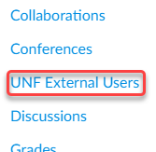

The Grant External Account Access page may take a minute to load if it does not appear to load at all contact CIRT at cirtlab@unf.edu or 620-3927.

- In order for your request to go through successfully you must provide all of the information exactly how it was entered in the original request.
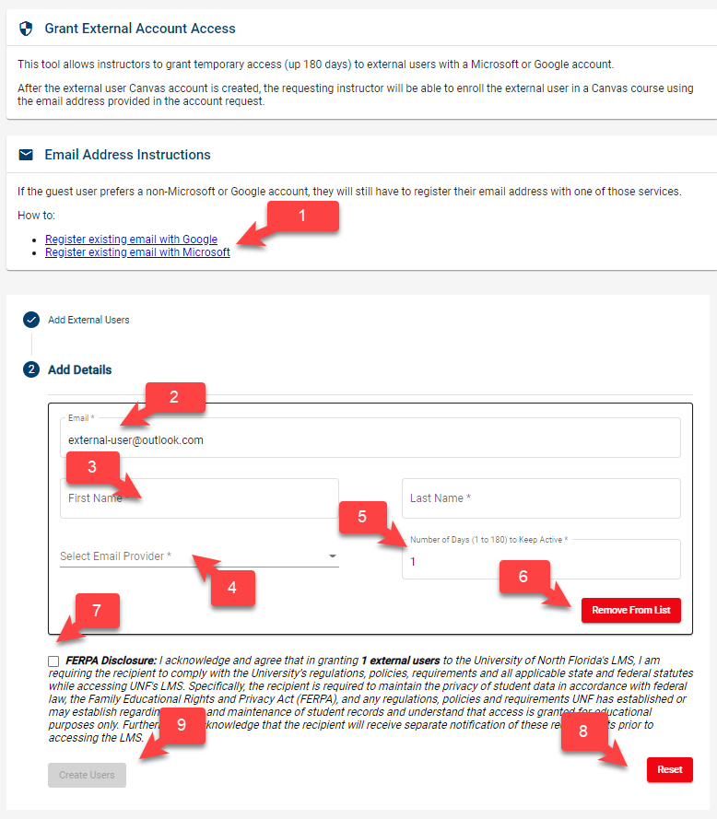
  - Email Address Instructions: Instructions on how external user can register for a Google or Microsoft Account (can be sent to the external user)
  - Email Address: The email address of the external user (preferably a Google or Microsoft address)
  - Name: First and Last name of the external user
  - Select Email Provider: Choose whether the external user will be using a Google or Microsoft account
  - Number of Days to Keep Active: 0 – 180 days, you can extend the active period at any time before the account expires.
  - Remove from List: If external user has been added in bulk and needs to be removed from list of users
  - FERPA Disclosure: Please read the full FERPA disclosure and select the checkbox
  - RESET: Clear all fields and start over.
  - CREATE USERS: Click to submit inputted information and create user. Note, this will send a confirmation email to the external user.

- Review the information to ensure it is typed in correctly and click the Create button. If the information does not match exactly a new account will be created instead of extending the existing account.
- You will immediately receive a confirmation message and you can either extend, or request, another user or leave the tool.
Shortly after the confirmation screen an account update email will be sent to you and the account holder containing information about the extension. If the request was made after the account became deactivated you can begin adding the account to courses again from the email address you registered it from.

