Canvas External User Access
Instructions on how to access Canvas from your Google or Microsoft account.

Important Information
- A Google or Microsoft accounts is necessary. If you do not have either, or prefer to use a different email address, below are instructions on how you can connect an existing email account to either service.
  - Register existing email with Google
  - Register existing email with Microsoft
- IMPORTANT: You can only access Canvas from the link provided in your new account email that is sent to you after your access has been granted.
- These instructions provide steps for how to access your account for the first time. After the initial login you will only need to click the Canvas link in your email and be taken directly to Canvas.

Contents

Access Canvas from Google 2
Access Canvas from Microsoft 4
Canvas Dashboard 6

Access Canvas from Google
- Login to your Gmail account and locate the email announcing your Canvas access.
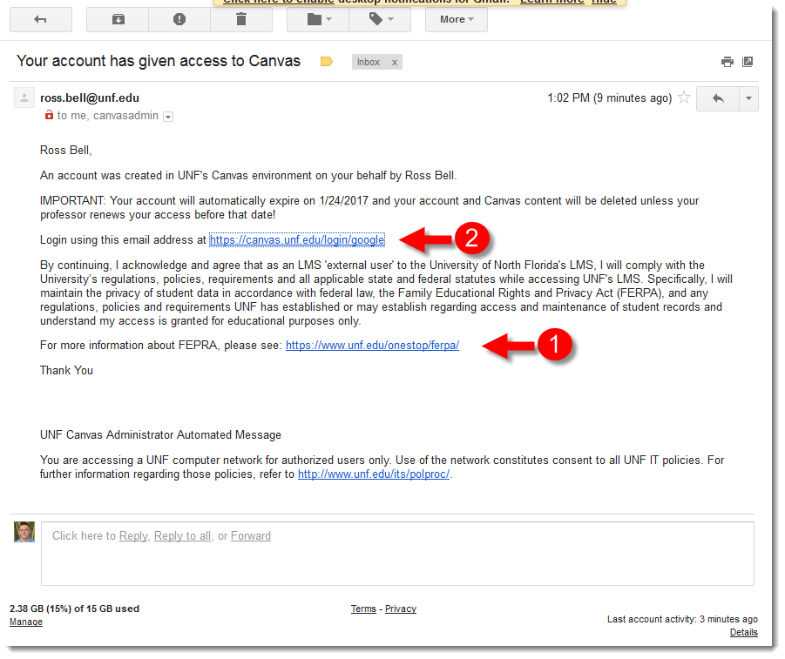
- Read the email in its entirety and the FERPA link [1].
- Once ready click the login link [2]. Bookmark this link, you will be required to use this URL for all future logins.
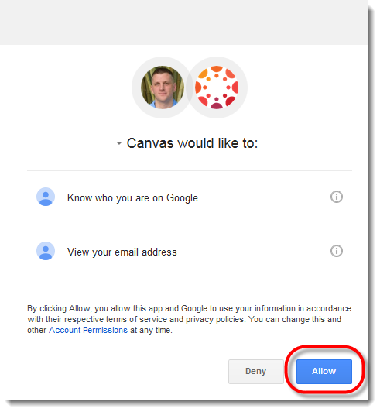
- Click the blue Allow button which authorizes Canvas to access this information from your Google account.
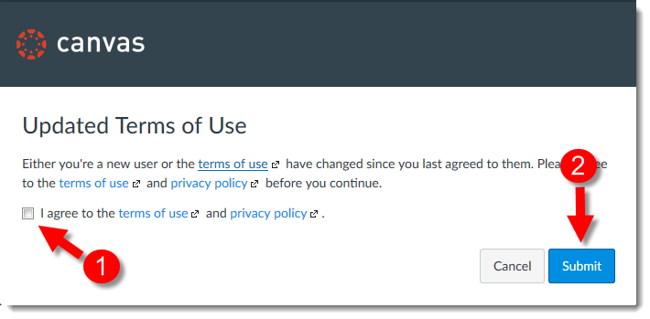
- Agree to the Canvas Terms of Use [1] and click Submit [2].
You will be taken directly to your Canvas Dashboard. Skip to the Canvas Dashboard for more information.

Access Canvas from Microsoft
- Login to your Microsoft account and locate the email announcing your Canvas access.
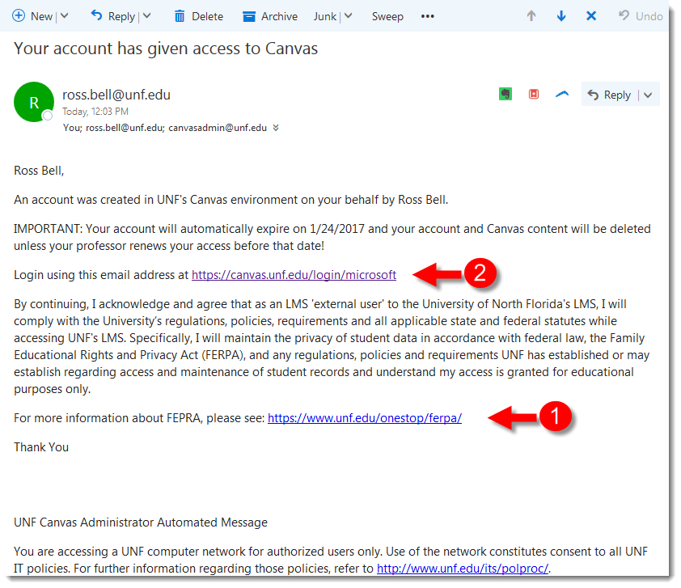
- Read the email in its entirety and the FERPA link [1].
- Once ready click the login link [2]. Bookmark this link, you will be required to use this URL for all future logins.
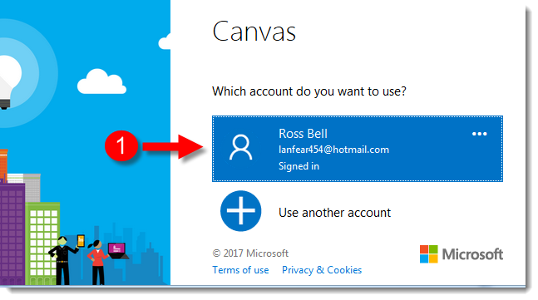
- You will be asked which Microsoft account you want to authorize, click the account.
You have now authorized Canvas to access your Microsoft account and will be automatically directed to Canvas. If this is your first time accessing Canvas with this external account you will be prompted to agree to its Terms of Use.
- Agree to the Canvas Terms of Use [1] and click Submit [2].
You will be taken directly to your Canvas Dashboard. Skip to the Canvas Dashboard for more information.

Canvas Dashboard
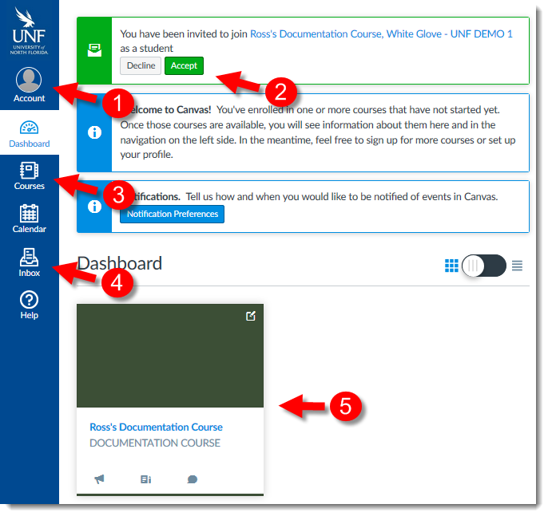
- Click to access your Profile and Notification settings.
- A course invite message. When you are invited to courses you must accept the invite before you can participate.
- Click to access a list view of your Canvas courses.
- Click to access your Canvas Inbox, internal messaging service.
- Course you are enrolled in, click to access the course.

