Granting External User Access

Prepared by Ross Bell
Instructions on how to request Canvas access for a user outside of UNF (external user).

Enabling the Tool
The External User Access tool is available from any course in Canvas and only for users with a Teacher role in the course. Which course you request the account from does not matter, and it does not automatically enroll the requested account into the course.
- Click Setting from your course menu
- Click the Navigation tab
- Drag and drop the External User Access tool into the active course navigation list
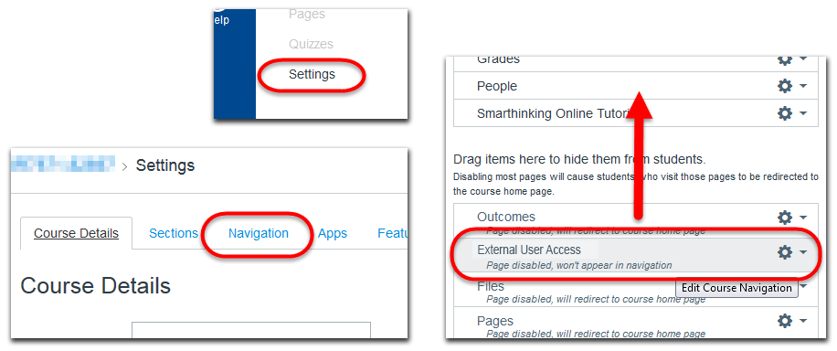
- Click the blue Save button at the bottom of the screen

Requesting Access
- Click External User Access from your course menu
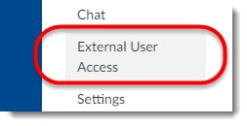
The Grant External Account Access page may take a minute to load if it does not appear to load at all contact CIRT at cirtlab@unf.edu or 620-3927

- In order for your request to go through successfully you must provide all of the requested information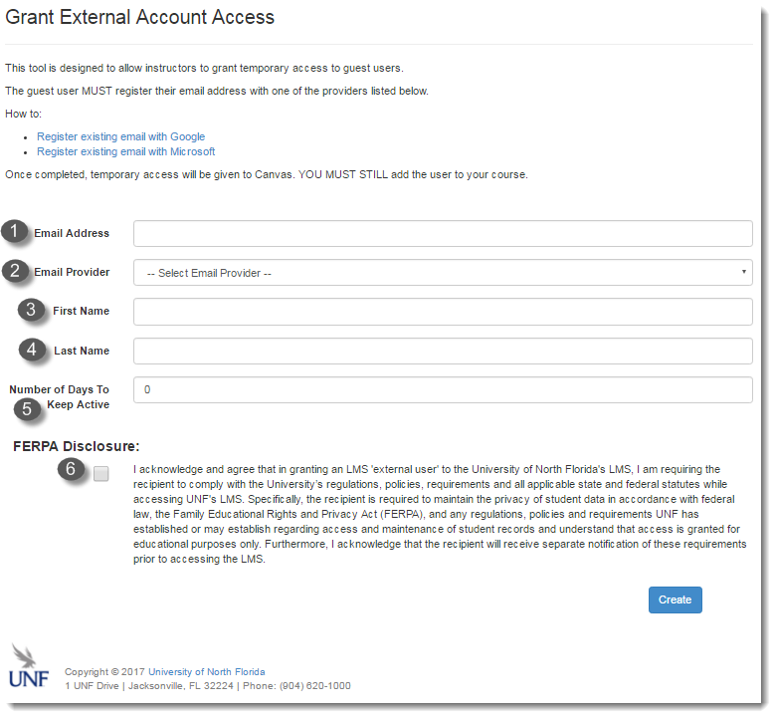
  - Email Address: The email address you are granting access to, this must be a Google address, Microsoft address, or an email address registered to either of those services
  - Email Provider: Select which provider the account is registered under
  - First Name: The first name of account holder
  - Last Name: The last name of account holder
  - Number of Days to Keep Active: 0 – 180 days, you can extend the active period at any time before the account expires see (instructions to come later)
  - FERPA Disclosure: Please read the full FERPA disclosure and select the checkbox

- Click the Create button
- You will immediately receive a confirmation number and you can either request another user or leave the page,
Shortly after the confirmation screen an email will be sent to you and the account holder with information on they are to access Canvas. At this time you can begin adding the new account to courses from the email address you registered it from.

Enrolling External User Accounts
Typically it is recommended that you only enroll users into a course by their N# due to their email address not being a reliable identifying factor (due to aliases), but when enrolling an external user account you must use their email account. Since the account was created with the email address given to you, you can be assured that you can locate the account from it.
- Starting in the course you want to enroll the account to, click People from the course menu.
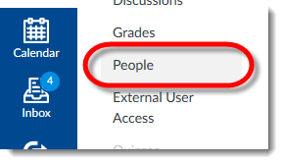
- From the People page, course roster, click the blue + People button at the top right of the roster.
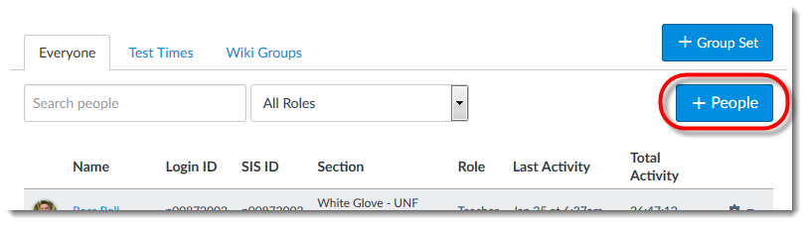
The Add People pop-up window will appear and from here you can add one or more Canvas users to your course at a time. When adding more than one users separate their email addresses, or N#, with a comma and you can only accept one role type for all of the users.
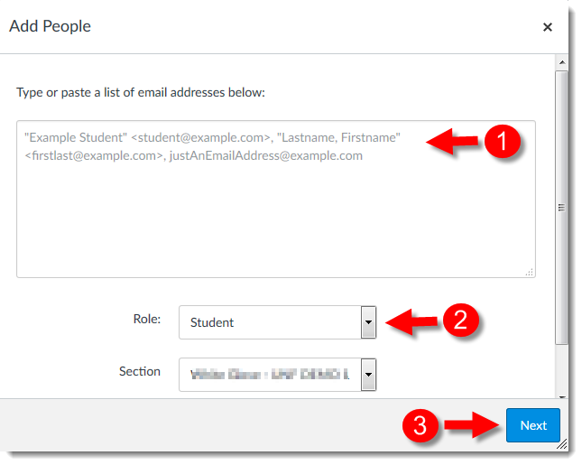
    - Type or copy n paste their email address (comma separate when adding multiple users).
    - Select their course Role.
    - Click the blue Next button.

You will receive a confirmation screen from which you can verify that the correct users are enrolled because their full name will appear next to the email address you entered. After confirming the accounts click the blue Add Users button to. The user(s) are now added to your course and they will be sent a course invite e-mail.

